1. **EVIDENCE OF TEACHING**
2. **MY TEACHING PHILOSOPHY**

I, Mohammed Firrdaus Bawa has adopted a teaching philosophy in education that believes that, all children, irrespective of their socio-cultural and economic backgrounds, are individually unique and must have a stimulating educational environment where they can physically, mentally, emotionally, and socially grow to their fullest of potentials. It is my aspiration to always create this type of atmosphere in all learning environments where pupils can meet their full potentials. I will provide a safe environment where pupils are invited to share their ideas and take risks. I believe that, there are five essential elements that are conducive to learning and they include;

1. The teacher's role is to act as a guide.
2. Pupils must have access to hands-on activities.
3. Pupils should be able to have choices and let their curiosity direct their learning.
4. Pupils need the opportunity to practice skills in a safe environment.
5. Technology must be incorporated into the school day.

I as a National Service Personnel and a professional teacher-to-be, always brings in an open mind, a positive attitude and very high expectations to the classroom, each and every day.

I also believe that a teacher is morally obligated to enter the classroom with only the highest of expectations for each and every one of his/her pupils. Thus, the teacher maximizes the positive benefits that naturally come along with any self-fulfilling prophecy. With dedication, perseverance, and hard work, his/her pupils will rise to the occasion."

Teaching is a process of learning from your pupils, colleagues, parents, and even the community in general. This is a lifelong process where one learns new strategies, ideas and philosophies. Over time, my educational philosophy may change, and that's okay. That just means that I have grown and learned new things.

1. **SCHEME OF LEARNING**

* **Present all schemes of work you prepared from the onset of National Service**

1. **LEARNING PLANS**

* **Provide not less than 15 lesson plans**
* **State whether each lesson was successful or not in the REMARKS column**
* **If some lessons were unsuccessful, clearly state the reason for the failure and indicate how that lesson could be re-taught to make it successful**

1. **TEACHING METHODS**

* **What is my relationship with my students**

I have built a strong and caring relationship with my students by constantly spending more time in helping them achieve their highest potentials in education and it is with this mindset that I believe, that, all children are unique and have something special that they can bring to their own education.

* **What are your responsibilities**

Aside the normal school hours, most of my students find me available to listen to their issues after school periods. This has given me the opportunity to coach and mentor some of them on certain moral values and give them general advices. I also use this time to help them do some of the assignments they find difficult doing.

* **What are the responsibilities of your students**

Every classroom should be a safe and a caring community where children are free to speak their mind and blossom and grow. Strategies have been used to ensure that, my classroom community flourishes with positive attitudes such as children obeying morning meetings to discuss the previous day’s problems, positive attitudes such as discipline, punctuality, obedience to school rules and regulations are encouraged and negative behaviors such as noise making and bullying are discouraged.

* **How does your relationship and the responsibility you carry affect your teaching**

My role as a teacher has helped most of my students to develop their own potential and learning styles. I have created a system that incorporates each of the different learning styles. Through the times I teach and the moments I share with them as their teacher, the relationship that I have built with them has made it possible to incorporate hands-on learning, cooperative learning, project and individual works that engage and activate pupils’ learning.

* **How does your teaching methods contribute to the achievement of learning objectives**

I believe that, I owe it to my pupils, as well as the community, to bring consistency, diligence and warmth to my job in the hope that I can ultimately inspire and encourage such traits in the children as well.

This positive thinking and attitude has promoted an effective participation of my learners during the teaching and learning process.

* **Are these methods necessary**

**YES**

* **How do you attend to the needs of students during teaching**

Since it is my belief that all learners deserve equal chances to learn, I evenly give concentration to all pupils when teaching. I do this by not regarding wrong answers as insults but rather, help pupils to come to know the right things.

* **Does your personality impact how you teach and does it also help you to achieve your objectives**

YES.

1. **TEACHING DEVELOPMENT**

* **Track your success story in teaching**

At the beginning of my induction period, there was a seemingly 'silent agreement' in BACE Model School that, sports and physical activities were meant for older males and that, the younger ones can only do some callisthenic exercises and as for the females, sports is a no-go area for them; they are discouraged from partaking in it even if they are really interested in doing so. Some of my pupils testified that, Physical Education or activity was used a sort of punishment back in their former schools. It is even 'normal' for a pupil to tell you that, "it is not force to do PE" or "PE is of no use to me" based on the experience that pupil had with other PE teachers. Some even contended with me that, "PE is for the low minded and has not scholars" which is not true.

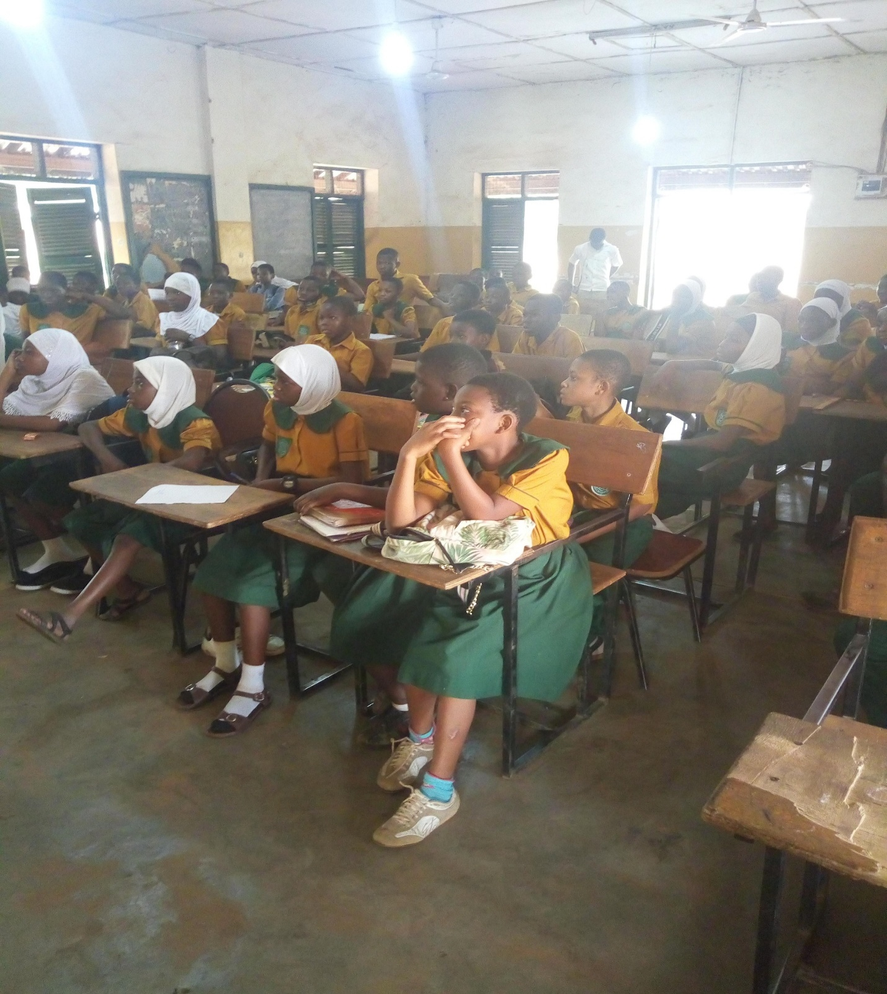**Figure 1** below shows the reluctance of pupils of BACE Model Junior High School from preparing themselves for a PE lesson as they continued to pay attention to a previous lesson.

I employed the services of role models to help me overcome this problem in a period of six (6) teaching weeks using three games; sprinting, football and handball. These role models were to serve as a form of intrinsic motivation for pupils to use in changing behavior towards practical Physical Education lessons and as well as encourage them to make meaningful participations during lessons.

After I applied this intervention, it was realized by all (teachers, parents and pupils themselves) at BACE Model Junior High School that:

1. Pupils (especially, females) developed great interest and eagerness in attending all PE lessons at the school’s field and their level of participation in these lessons since then has been outstanding.
2. Pupils pretending to be tired and or feeling sleepy before the start of PE lessons were now seen to be the first in reporting to the field whenever there was a lesson.
3. The researcher's two (2) asthmatic pupils who never had a reason to participate in his lessons due to their condition, now took part in every task without complaining or showing any sign of fatigue or loss of breath during lessons as if they had an antidote.
4. Pupils built better relationships amongst themselves as team mates.
5. On two occasions, pupils had to plead with other teachers to forfeit their lesson periods to them to use for their PE lessons; these two days happened to fall on national holidays.
6. Pupils have now decided to always avail themselves to the researcher even on weekends just to partake in calisthenics and sport games.

* **What methods have you adopted in order to improve upon the success of your students academics**

A strategy was developed to use only thirty minutes of my learners’ time, on every Friday after the close of lessons, to assess them on some of the key areas they have difficulties in and also guide them through on how to overcome them.

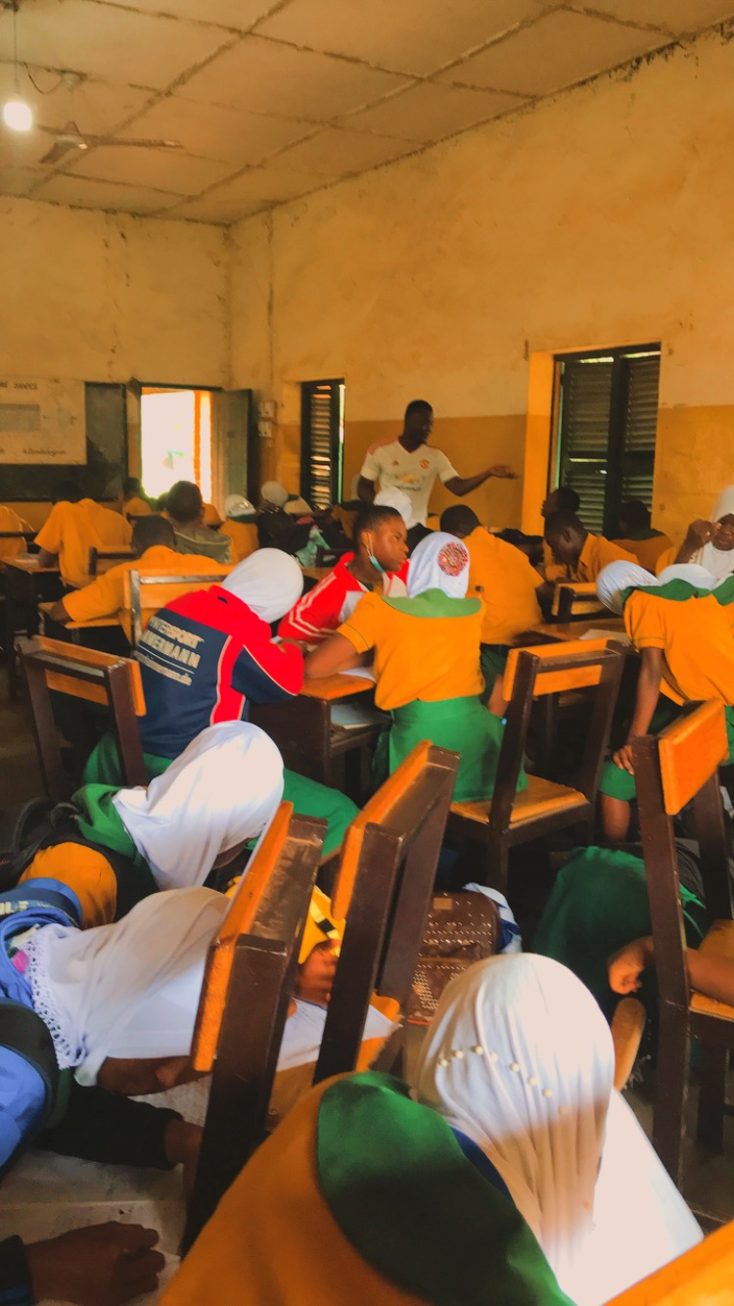

* **What are your weaknesses and how are you working on them for improvement**

Familiarizing myself with the Common Core Program (new curriculum). I have attended a seminar and two workshops and I still continue to depend on the guidance of my mentor and colleagues in getting used to the new teaching system.

* **How are you making your teaching public**

I am currently organizing to teach some learners for different schools on weekends.

1. **TEACHING LEARNING RESOURCES**

I am fortunate to be provided with the following Teaching and Learning Resources:

* Projector for Power Point Presentations and showing educational videos.

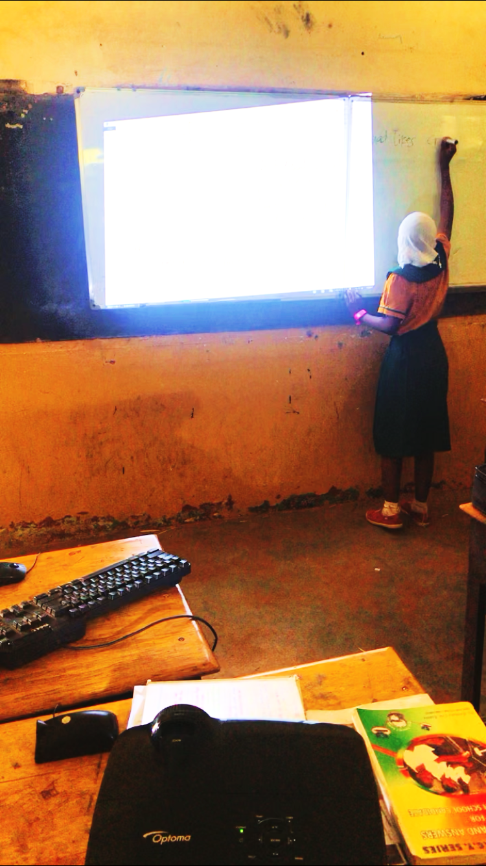

* Sports equipment for practical Physical Education Lessons
* Cultural artifacts for the teaching of Creative Arts and Design

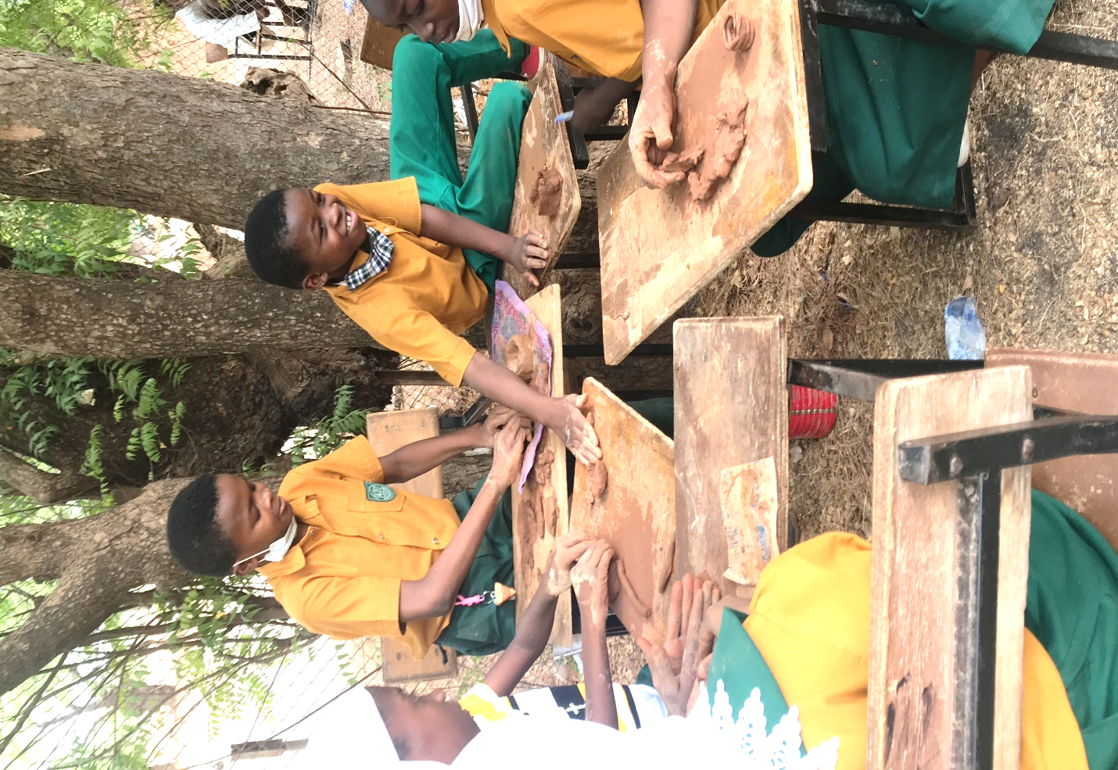

1. **FORMATIVE AND SUMMATIVE ASSESSMENT**
2. **IDENTIFICATION OF LEARNERS’ NEEDS**

ACTION RESEARCH FOR ONLY ONE PERSON

1. **PROFESSIONAL DEVELOPMENT**

* **INSET**
* **CPD**
* **Group works (by students)**
* **Presentations (by students)**
* **Project works (by students)**

1. **SAMPLES OF LEARNERS WORK ASSESSED**
2. **CO-CURRICULAR ACTIVITIES**

* **STEM**
* **PE**
* **CAD**

1. **CORE COMPETENCIES**

* **Refer to the curriculum**
* **STEM (How to make a balloon car)**
* **STEM (designing)**
* **Presentation**
* **Presentation**
* **Form teacher**
* **ICT**

1. **SAMPLES OF LEARNERS’ WORK**
2. **FORMAL MEETINGS WITH MENTOR**

* **Staff meeting**
* **ICT Lab**

1. **EVIDENCE OF IN-SERVICE TRAINING WORKSHOP/CPD**

* **New Curriculum workshop**
* **Lois’ pictures**

1. **MENTOR’S COMMENT**
2. **DIRECTOR’S COMMENT**

|  |  |
| --- | --- |
| **KEY** | **COLOUR CODE** |
|  | To be provided by head teacher or mentor |
|  | To be physically verified by portfolio assessors |
|  | All lesson plans must have evaluations and assignments. Some of these assignments must be done during the lesson delivery process and others, after. |
|  | Make a copy of your project-work available |
|  | Get a meeting minutes ready |